Vehicle detection in allocated parking space using camera image

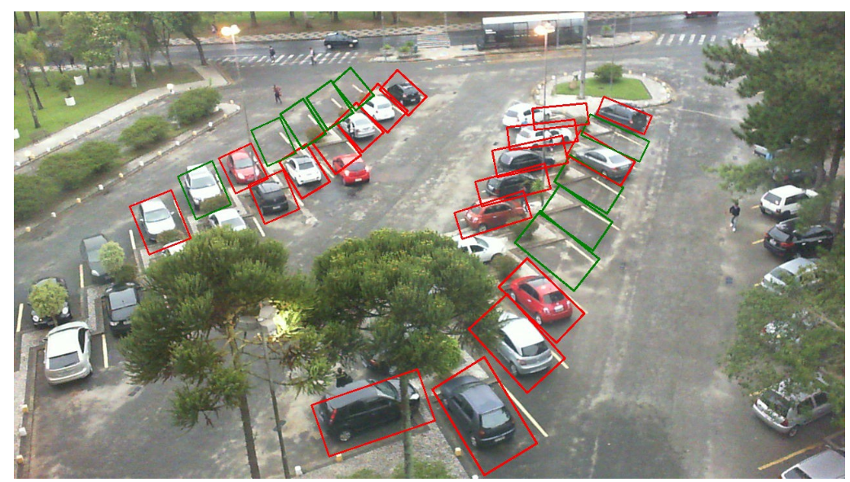

This application is through find white line of car space to detect position of car space.

The application implemented an AI algorithm that takes in an annotated image and draws a green coloured bounding box around the parking space if it is available and a red coloured bounding box if it is occupied. This included training a deep convolutional neural network to detect if a parking space is occupied or not.it trained a VGG model using transfer learning. It means to create image of empty car space of each rect and then compare those images with each frame of video. That allow system to detect is the free of car space.

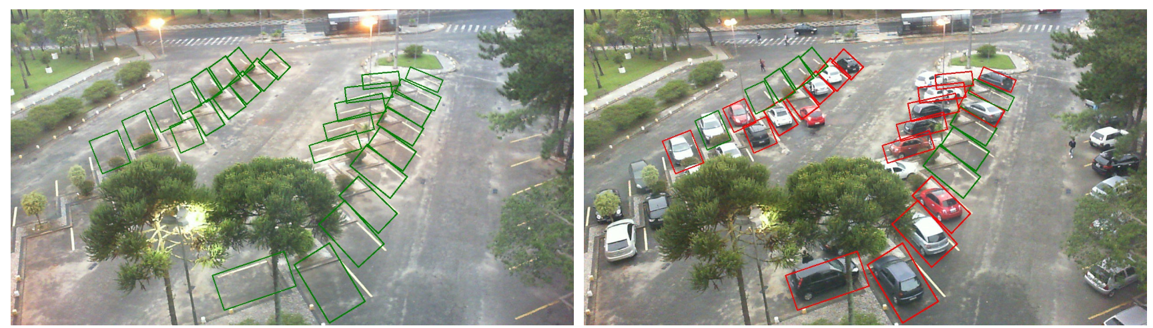

Advantages:

1. The trained model was able to achieve 99.5% accuracy on the validation set.
2. This application shows each rect of car space very clearly.

Disadvantages:

1. If barrier exists on the screen to hide line of car space, the system can not detect those position of car space.
2. Have to train VGG model by manual work, can only use for one car park.
3. It is difficult to detect white line when white line getting dim.

Snagging Parking Spaces with Mask R-CNN and Python

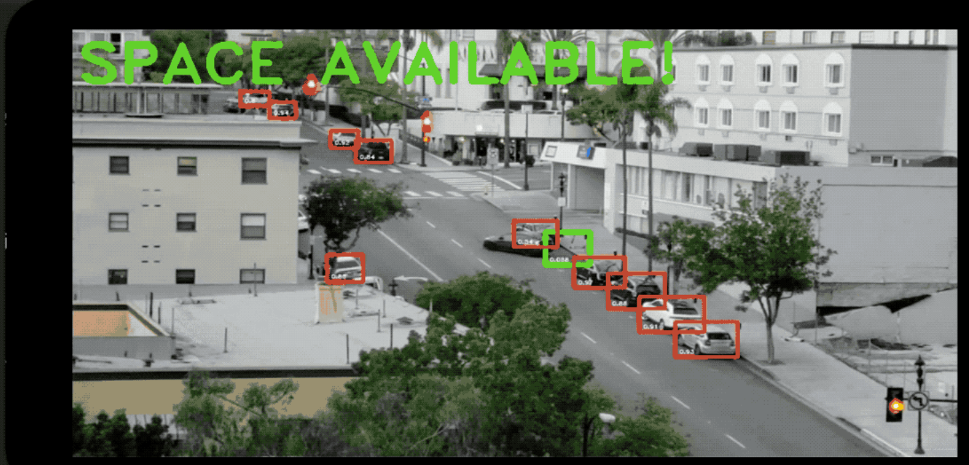

This application is use mask R_CNN to detect location and outline of car(ima1). This application through moving of car to check which position is car space, for example, if this car don’t move over 5 mins, then this position is car space, then draw a box in this position, if car move then change green box to red box finally send image and text by message to the user, tell user there have a car space available(ima2).

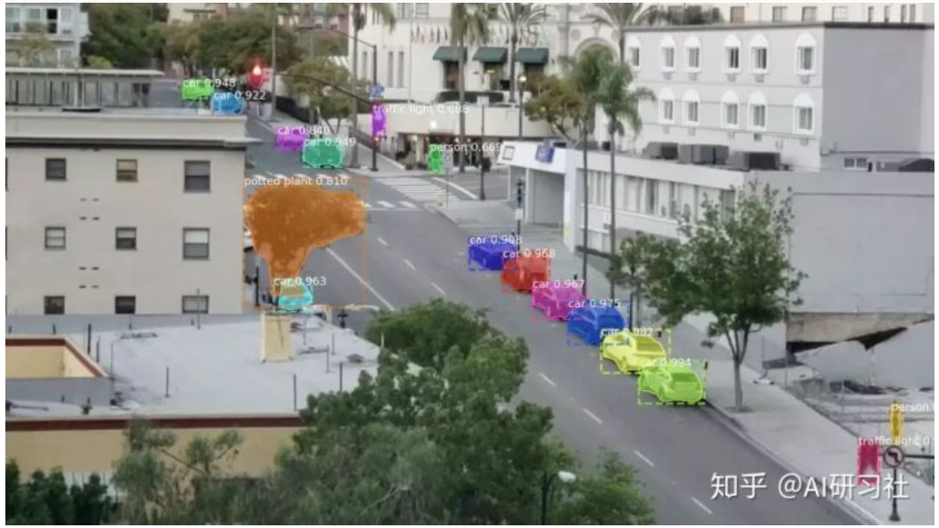

Ima1

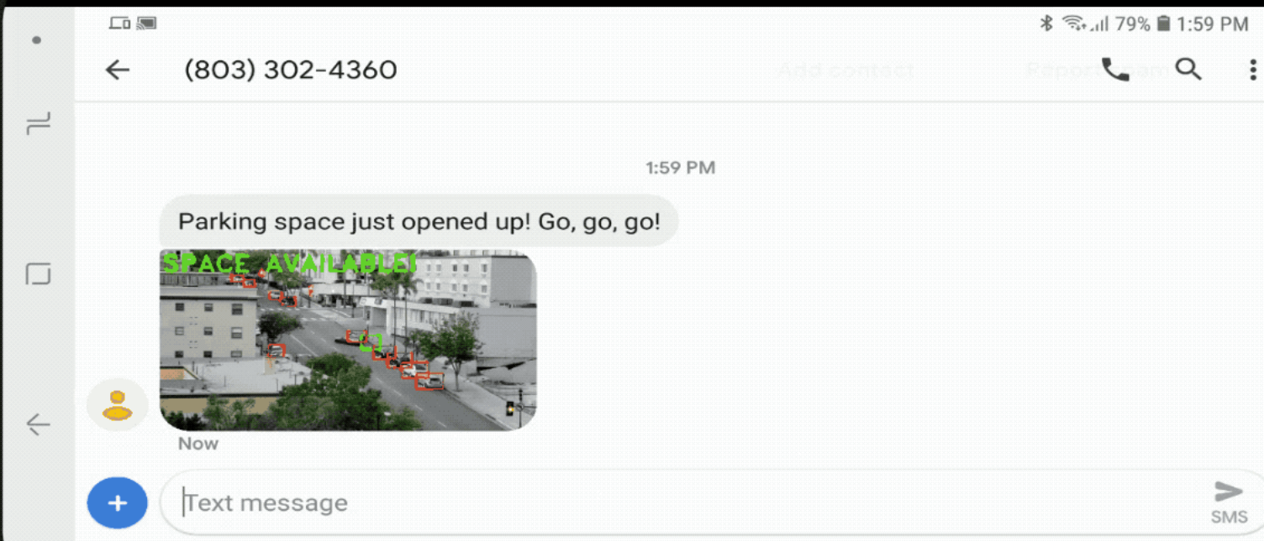

Ima2

Advantages:

1. It is easy to detect where is cars.
2. Don’t need manual work, system going to solve everything.
3. Shows red box and green box clearly.

Disadvantages:

1. It is difficult to detect cars when some barrier hide car.
2. If a car stays more than 5 mins on the other space, the system will Determine the position is car space.

Use opencv&tensorflow to detect car space

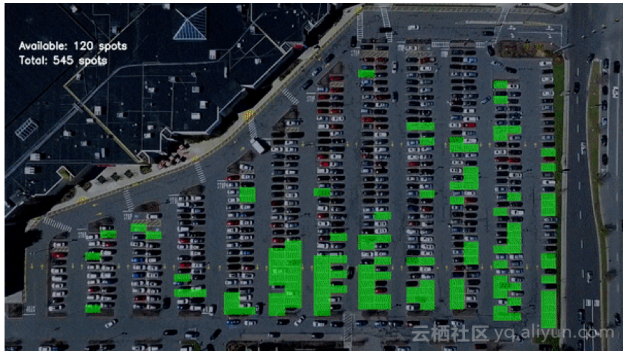

This application is use edge detection, hough transform to draw all of the car space(img3). Then allocate id for each car space. This application create a cnn model to create image of empty car space and car space which have car exists, That allow system to detect is the free of car space. (img4)

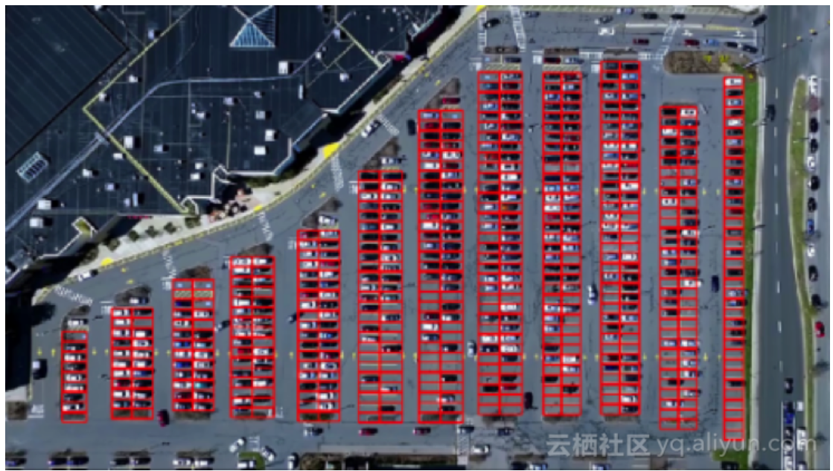

Img3

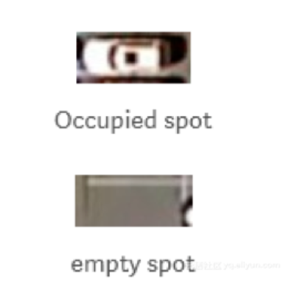

Img4

Advantages:

1. High accurate
2. Able to recognition small cars.
3. Shows number of car space available and total car space

Disadvantages:

1. The system may recognition space is not belonging car space.
2. Still have mistaken exists.

References:

<https://segmentfault.com/a/1190000016849300>

<https://towardsdatascience.com/smart-parking-an-application-of-ai-9a4af90b1de6>

<https://medium.com/@ageitgey/snagging-parking-spaces-with-mask-r-cnn-and-python-955f2231c400>